 | COMPETENCY BASED QUESTIONS
 | Name of the chapter:SEXUAL REPRODUCTION IN FLOWERIG PLANTS.
1. | Read the following and answer any four questions from (i) to (v) given below:  Cross pollination is the transfer-of pollen grains from the anther of a one flower to the stigma  of a genetically different flower. It is performed with the help of an external agency which may  be abiotic (e.g., wind, water) or biotic (e.g., insects, birds, bats, snails). The diagram shows  the carpel of an insect pollinated flower.  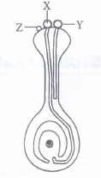  (i) What is the most likely reason for non germination of pollen grain Z?  (a) Pollen grains X and Y were brought to the stigma earlier, therefore, their germination inhibited the germination of pollen grain Z.  (b) Pollen grain Z was brought to the flower by wind, while pollen grains X and Y were broughtto the flower by insect  (c) Pollen grain Z lacks protrusions that allow it to adhere properly onto the stigma surface  (d) Pollen grain Z comes from a flower of an incompatible species  (ii) Which of the following best describes the function of the pollen tube?  (a) It acts as a conduit to transport male gametes from the anther to the ovule  (b) It acts as a conduit to transport male gametes from the stigma to the ovule.  (c) It contains key nutrients that serve to nourish the newly-formed zygote  (d) It digests the tissues of the stigma, style and ovary.  (iii) Pollination of a flower in which the pollen is carried by an insect is called  (a) anemophily (b) ornithophily (c) entomophily (d) malacophily.  (iv) Refer to the given charactericstics of some flowers  A. The stamens hang out of the flower, exposing the anthers to the wind. B. The pollen grains are tiny and light - The flower has a sweet scent. D. The flower petals are brightly coloured.  How many of the above characteristics are of insect-pollinated flower?  (a) One (b) Two (c) Three (d) Four  (v) Pollenkitt is generally found in  (a) anemophilous flowers (b) entomophilous flowers (c) ornithophilous flowers (d) malacophilous flowers.  2.The meiocyte of an Onion plant contains 32 chromosomes. Work out the number of chromosomes found in its endosperm.  3.Directions: In the following questions, a statement of assertion is followed by a statement of reason.  Mark the correct choice as:  (a) If both Assertion and Reason are true and Reason is the correct explanation of Assertion.  (b) If both Assertion and Reason are true but Reason is not the correct explanation of Assertion.  (c) If Assertion is true but Reason is false.  (d) If both Assertion and Reason are false.  Q.1. Assertion : Autogamy is a transfer of pollen grains from an anther to the stigma of the same flower on the same plant.  Reason : Xenogamy is pollination between two flowers on different plants.  Q.2. Assertion : Insects visit flower to gather honey.  Reason : Attraction of flowers prevents the insects from damaging other parts of the plant  Q.3. Assertion : Pollen mother cells (PMCs) are the first male gametophytic cells.  Reason : Each PMC gives rise to two pollens  Q.4. Assertion : Chasmogamous flowers require pollinating agents.  Reason : Cleistogamous flowers do not expose their sex organs.  Q.5. Assertion: Gynoecium consists of pistil.  Reason: It represents the male reproductive part in flowering plants.

 | NAME OF THE CHAPTER: HUMAN REPRODUCTION
1. | Ramesh got a job in Mumbai but his family was still living in the village. One day, he received a letter from his father stating that he is planning marriage of her sister who will be fifteen years old in March. Ramesh did not like the idea of his father of arranging plan of his sister till she attains age of 18 years.  Read the above passage and answer the following questions:  (i) In your opinion, who is right Ramesh or his Father?  (ii) What is the right age of marriage for girls?  (iii) What are the risks involved in early marriage?
2. | Roma is working woman and gave birth to a baby two weeks ago. Due to very hectic schedule, she asked her mother-in-law to feed the powdered milk to the baby. On the other hand, mother-in-law insisted on breastfeeding.  Read the above passage and answer the following questions:  (i) In your opinion who is the right Roma or her mother-in-law?  (ii) Why is breastfeeding important?  (iii) What health problem can mother face in case she does nor breastfeed the baby?
 | Assertion-ReasonBasedquestion
Note: In the following questions a statement of assertion followed by astatementofreasonisgiven.Choosethecorrectansweroutofthefollowingchoices.
- Bothassertionandreasonaretrueandthe reasonisthecorrectexplanationofassertion.
- Bothassertionandreasonaretrueandthe reasonisnotthecorrectexplanationofassertion.
- Assertionistruebutthereasonisfalse.
- Assertionisfalsebutthereasonistrue.

1. | Testicular lobules are the compartments present in testes.  Reason : These lobules are involved in the process of fertilization.
2. | Interstitial cell is present in the region outside the seminiferous tubule called interstitial  spaces.  Reason : Interstitial cells provide nutrition to the sertoli cells.
3. | In human male, there are perianal glands near the anus.  Reason: Perianal glands secretes sex-attractant pheromone which initiates sexual desire in human.
4. | The female external genitalia includes mons pubis, labia majora and labia minora.  Reason: The glandular tissue of each breast is divided into 5-10 mammary lobes.
 | Multiple choice Question
i | Q.1. The correct sequence of stages in spermatogenesis are:  (a) spermatogonia → spermatid → spermatocyte → sperm  (b) spermatocyte → spermatogonia → spermatid → sperm  (c) spermatogonia → spermatocyte → spermatid → sperm  (d) spermatid → spermatocyte → spermatogonia → sperm
ii | The signals of parturition originate from  (a) placenta  (b) fully developed foetus  (c) oxytocin released from pituitary  (d) both placenta and fully developed foetus
iii | Identify the odd one from the following.  (a) Labia minora  (b) Fimbriae  (c) Infundibulum  (d) Isthmus
iv | Choose the incorrect statement from the following.  (a) In birds and mammals internal fertilisation takes place.  (b) Colostrum contains antibodies and nutrients.  (c) Polyspermy in mammals is prevented by the chemical changes in the egg surface.  (d) In the human female implantation occurs almost seven days after fertilisation.
v | Seminal plasma, the fluid part of semen, is contributed by.  (i) Seminal vesicle (ii) Prostate gland (iii) Urethra (iv) Bulbourethral gland  (a) (i) and (ii)  (b) (i), (ii) and (iv)  (c) (ii), (iii) and (iv)  (d) (i) and (iv)

COMPETENCY BASED QUESTIONS
Nameofthe chapter:REPRODUCTIVE HEALTH
CASE BASED QUESTIONS
1. | Study the diagram of the female reproductive system given below. Answer the questions based on the diagram  .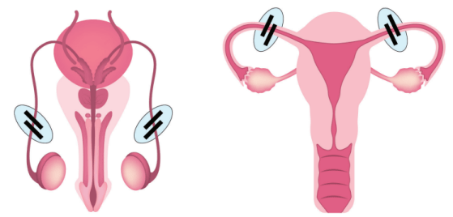  (i) What does the diagram depict?  (ii) At what stage zygote can be introduced in the fallopian tube in Zygote Intra FallopianTransfer (ZIFT)?  (iii) Mention any two events that are inhibited by the intake of oral contraceptive pills to prevent pregnancy in humans
i | Multiple choice Question  Which Artificial Reproductive Technique can help a lady conceive a child if both her fallopian tubes are blocked?  - SUZI  - IVF  - ZIFT  - GIFT
ii. | What is the shape of the growth curve?  - S-shaped  - V-shaped  - C-shaped  - J-shaped
iii. | Test tube baby implies which of the following techniques?  - IUI  - ICSI  - GIFT  - ZIFT
iv. | The programs to get total reproductive health as a social goal at the national level are called  - Family organisation  - Family planning  - Family care  - Reproductive care
Assertion and Reason
Directions: In the following questions, a statement of assertion is followed by a statement of reason.
Mark the correct choice as:
(a) If both Assertion and Reason are true and Reason is the correct explanation of Assertion.
(b) If both Assertion and Reason are true but Reason is not the correct explanation of Assertion.
(c) If Assertion is true but Reason is false.
(d) If both Assertion and Reason are false.
i | Q.1. Assertion: A person should be considered reproductively healthy if they have healthy reproductive organs but are emotionally imbalanced.  Reason: This statement about reproductive health was given by WHO.
ii | Assertion: Reproductive and Child Healthcare Programmes is for reproduction related areas.  Reason: It deals with creating awareness among various reproduction related aspects.
iii | Assertion: Natality increases both population density and population size.  Reason: Natality increases the number of individuals in an area by births.
iv | Assertion: Rapid decline in death rate, MMR and IMR have lead to a staggering rise in population.  Reason: Such an alarming growth rate has lead to an absolute scarcity of even the most basic requirements, i.e. food and shelter.
v | Assertion: Zero population growth should be achieved as early as possible to control human population.  Reason: This as requires not two children per couple but a little more.

Name of the chapter:Principle of Inheritance and Variation
1 | Directions: In the following questions, a statement of assertion is followed by a statement of reason.  Mark the correct choice as:  (a) If both Assertion and Reason are true and Reason is the correct explanation of Assertion.  (b) If both Assertion and Reason are true but Reason is not the correct explanation of Assertion.  (c) If Assertion is true but Reason is false.  (d) If both Assertion and Reason are false.
1 | Assertion: Mendel used true-breeding pea lines for artificial pollination experiments for his genetic studies.  Reason: For several generations, a true-breeding line shows the stable trait inheritance and expression.
2 | Assertion: A good example of multiple alleles is ABO blood group system.  Reason: When IA and IB alleles are present together in ABO blood group system, they both express their own types.
1.  2. | Case based Question  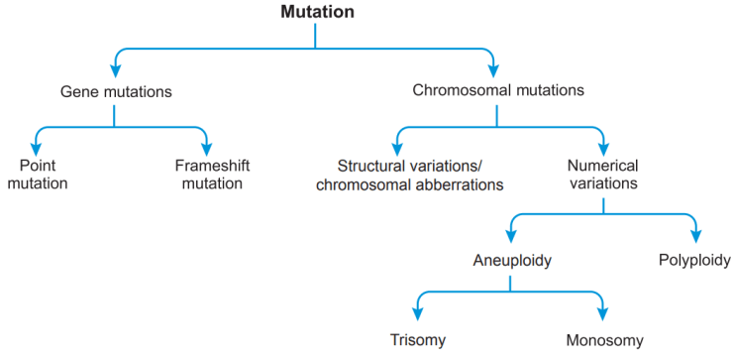Study the flowchart given below and answer the questions that follow.  - What is a mutagen? Name a physical factor that can be mutagen.  (ii) What is point mutation? Give one example.  (iii)Mention two causes of frame-shift mutation  During a study on the inheritance of two genes, the teacher asked students to perform an experiment. The students crossed white-eyed, yellow-bodied female Drosophila with a red-eyed, brown-bodied male Drosophila (i.e., wild). They observed that progenies in F2 generation had 1.3 percent recombinants and 98.7 percent parental type combinations. The experimental cross with results is shown in the given figure.[Note: Dominant wild-type alleles are represented with (+) sign in superscript.]  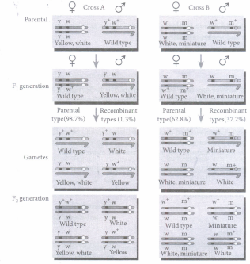  (i) By conducting the given experiment, the teacher can conclude that  A. Genes for eye color and body color are linked  B. Genes for eye color and body color show complete linkage  C. Linked genes remain together and are inherited  ii) Teacher asked to conduct an experiment on Drosophila because  (a) the male and female flies are easily distinguishable (b) it completes its life cycle in about two weeks  (c) a single mating could produce a large number of progeny flies (d) all of these.
1. | Multiple choice Questions  Cause of chromosomal mutation:  (a) Euploidy  (b) Polyploidy  (c) Physical effect  (d) All of these
2. | Mendal’s law can be applicable only when:  (a) Characters are linked  (b) Parents are pore breed  (c) F1 generation in monohybrid cross show 2 type of individuals  (d) Onepair of contiasting characters depends on another pair
 | Name of the chapter:Biotechnology Principle and processes
1. | Read the following and answer any four questions from (i) to (v) given below:  Gene manipulation is a fast-emerging science. It started with development of recombinant DNA molecule. It is named variously as DNA manipulation biotechnology, recombinant DNA technology and genetic engineering. This technology, that mostly involves cutting and pasting of desired DNA fragments, is based on two important discoveries in bacteria, i.e., presence of plasmid in bacteria and restriction endonucleases. Paul Berg was able to introduce a gene of SV-40 into a bacterium. The science of recombinant DNA technology took birth when Cohen and Boyer (1973) were able to introduce a piece of gene containing foreign DNA into plasmid of E. coli.  (i) Biotechnology is also known as  (a) DNA manipulation biotechnology (b) recombinant DNA technology  (c) genetic engineering (d) all of these.  (ii) A bacterial plasmid is a/an  (a) extra chromosomal material that do not replicate (b) extra chromosomal material that undergo replication with or without chromosomal DNA  (c) tubular structures that help in conjugation (d) bristle like solid structure that help in adhesion.  (iii) Father of genetic engineering is  (a) Paul Berg (b) Arber (c) Nathan (d) Smith.  (iv) Which of the following is used by Paul Berg to introduce a gene of SV-40 in a bacterium?  (a) E. coli (b) cos-plasmids (c) Lambda phage (d) None of these  (v) Read the given statements and select the correct option.  Assertion : Biotechnology started with the development of recombinant DNA molecule.  Reason : Biotechnology mostly involves cutting and pasting of desired DNA fragments.  (a) Both assertion and reason are true and reason is the correct explanation of assertion.  (b) Both assertion and reason are true but reason is not the correct explanation of assertion.  (c) Assertion is true but reason is false.  (d) Both assertion and reason are false.

2. | The foundations of recombinant DNA (rDNA) were laid by the discovery of restriction enzymes. These enzymes are present in many bacterias where they function as a part of their defense mechanism called the Restriction Modification system (RM system). Molecular basis of this system was explained first by Werner Arber in 1962. The Restriction t-'l0dification system consists of two components:  1. A restriction enzyme (called restriction endonuclease) identifies the introduced foreign DNA and cuts it into pieces.  2.The second component is a modification enzyme (methylase) that adds a methyl group to DNA at specific site to protect it from the restriction enzyme cleavage.  (i) Restriction endonucleases are enzymes present in (i) where they function as a part of (ii) mechanism.  (a) (i) bacteria (ii) digestive (b) (i) protists (ii)transcription (c) (i) plant cells (ii) replication (d) (i) prokaryotes (ii)defence  (ii) Which of the following statements regarding modification enzyme is correct?  (a) It adds methyl group to one or two bases usually within the host DNA sequence to protect it from the restriction enzyme.  (b) It adds ethyl group to one or two bases usually within the sequence recognised by the restriction enzymes.  (c) It adds methyl group to only one of bases within the foreign DNA sequence that is recognised by the restriction enzymes.  (d) None of these  (iii) Which of the following is a type II restriction enzyme?  (a) Alu I (b) EcoR I (c) BamH I (d) All of these  (iv) Which of the following is the first discovered restriction endonuclease?  (a) Sal I (b) EcoR I (c) Hind II (d) EcoR II  (v) Components of Restriction Modification System include  (a) restriction enzyme (b) modification enzyme (c) lysing enzyme (d) both (a) and (b).
3. | A schematic representation of the steps in Polymerase Chain Reaction (PCR) is shown below. Answer the questions that follow:  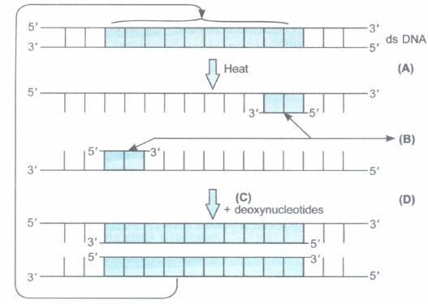  (a) Name the steps A and D in the PCR.  (b) Identify B. What are they chemically?(c) What is C? Name its source organism.
1. | - Multiple choice Questions  How many DNA molecules are formed from a DNA template molecule after 4 PCR cycles?  (a) 4  (b) 32  (c) 16  (d) 8
2. | Which of the following statements about cloning vectors is false?  (a) ‘Ori’ is a sequence responsible for controlling the copy number of the linked DNA  (b) Selectable marker selectively permitting the growth of the non-transformants  (c) To link the alien DNA, the vector needs to have a single recognition site for the commonly used restriction enzymes  (d) The ligation of alien DNA is carried out at a restriction site present in one of the two antibiotic resistance genes
3. | Ti-plasmid used in genetic engineering was modified by?  (a) adding tumour forming genes  (b) deleting tumour forming genes  (c) adding genes for endonucleases  (d) deleting genes for endonucleases

COMPETENCY BASED QUESTIONS
Name of the chapter: Organisms and Population
CASEBASEDQUESTIONS
1. | Question 1:Organism P has thick lips and tongue so that it can easily feed on the commonly available spiny plants. Organism Q has thick layer of insulating fat under the skin. It was strong hooves to walk steadily on steep surfaces and lives in burrows during winters. Organism R has bright colours and sticky pads on its fingers and toes. It lives on trees.  (i) Which of the following is correct habitat for organisms P regarding its adaptation?  (a) Grassland biome  (b) Desert biome  (c) Tropical rainforest  (d) Tropical deciduous forest  (ii) Which of the following is correct match regarding organism Q and its habitat?  (a) Tundra – Polar bear  (b) Tropical rain forest – Deer  (c) Grassland – Bighorn sheep  (d) Desert – Camel  (iii) Which of the following is incorrect regarding organisms R’s habitat?  (a) The vegetation shows stratification  (b) Epiphytic growth is rich  (c) Standing crop is highest  (d) Deep rooted shrubs are common due to abundant sunlight  (iv) The dominant plants in habitat where P lives could be  (a) Opuntia  (b) Nymphaea  (c) Deodar  (d) both (a) and ©  v) Organisms P, Q and R respectively most likely occur in  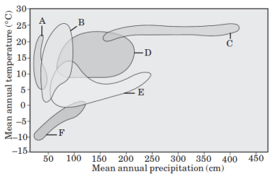  a) F, B and A  (b) C, A, E  (c) A, F and C  (d) B, D and A.  Assertion and Reasoning  Directions: In the following questions, a statement of assertion is followed by a statement of reason.  Mark the correct choice as:  (a) If both Assertion and Reason are true and Reason is the correct explanation of Assertion.  (b) If both Assertion and Reason are true but Reason is not the correct explanation of Assertion.  (c) If Assertion is true but Reason is false.  (d) If both Assertion and Reason are false.  Q.1. Assertion : Tropical rain forests are disappearing fast from developing countries such as India.  Reason : No value is attached to these forests because these are poor in biodiversity.  Q.2Assertion : Flora contains the actual account of habitat and distribution of plants of a given area.  Reason : Flora helps in correct identification.  Q.3. Assertion : Species are groups of potentially interbreeding natural populations which are isolated from other such groups.  Reason : Distinctive morphological characters are displayed due to reproductive isolation.  Q.4. Assertion: “The Biological Species” concept helps us to ask how species are formed.  Reason: The concept of biological species focuses our attention on the question of how reproductive isolation comes about.  Multiple choice Question  Q .1. Salt concentration (salinity) of the sea measured in parts per thousand is:  (A) 10-15 (B) 30-70 (C) 0-5 (D) 30-35  Q.2. Formation of tropical forests needs mean annual temperature and mean annual precipitation as:  (A) 18 – 25 °C and 150 – 400 cm  (B) 5 – 15 °C and 50 – 100 cm  (C) 30 – 50 °C and 100 – 150 cm  (D) 5 – 15 °C and 100 – 200 cm  Q.3. Ecological niche is:  (A) The surface area of the ocean  (B) An ecological adapted zone  (C) Physical position and functional role of a species within the community  (D) Formed of all plants and animals living at the bottom of lake  - 4. Which of the following forest plants control the light conditions at the ground?  (A) Lianas and climbers (B) Shrubs  (C) Tall trees (D) Herbs  Q.5Ecotone is:  (A) A polluted area  (B) The bottom of a lake  (C) A zone of transition between two communities  (D) A zone of developing community  Name of the chapter:BIODIVERSITY AND ITS CONSERVATION  Case based Questions  - The global animal diversity is shown in the pie charts (A-Invertebrates and B-Ve.rtebrates) drawn below.  Answer the questions that follow.  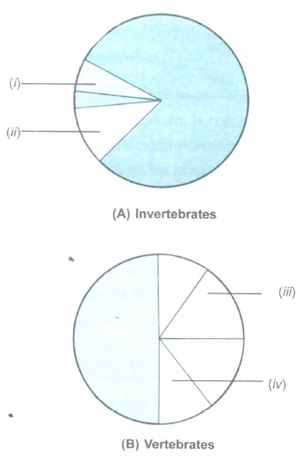  (a) Name the animal groups that are represented by the areas shaded black in A and B, respectively. Also, mention the kind of habitat, where you would find these groups of animals.  (b) Identify the following groups of animals in the pie diagrams: Crustaceans and Amphibians.  - When a graph showing species-area relationship on a logarithmic scale, the relationship is a straight line. Ecologists have discovered that the value of z-line lies in the range of 0.1 and 0.2 irrespective of the taxonomic group or the region.  (a) When will the stope become much steeper with higher Z-values? Give an example.  (b) What do steeper slopes mean in this context?  - It is learnt from the study of the history of life on earth through fossil records that there were large scale losses of species. Since the origin and diversification of life forms on the earth, there were five episodes of mass extinction. The 'Sixth Extinction' is presently in progress.  (a) Give two points as to how this sixth episode is different from the earlier episodes.  (b) What do the ecologists warn about the current trend?  (c) Mention the three effects of loss of biodiversity in a region.  - Faced with conflict between development and conservation, many nations find it unrealistic and economically not feasible to conserve all their biological wealth. On a global basis, eminent conservationists have identified certain regions as 'Biodiversity hotspots' for maximum protection.  (a) Mention two criteria for a region to be called a 'biodiversity hotspot'.  (b) Name two biodiversity hotspots in India.  (c) Hotspots occupy less than 2 per cent of the earth's land area. Yet, they are given priority for conservation of biodiversity. Give two reasons  ASSERTION AND REASON
Directions: In the following questions, a statement of assertion is followed by a statement of reason.
Mark the correct choice as:
(a) If both Assertion and Reason are true and Reason is the correct explanation of Assertion.
(b) If both Assertion and Reason are true but Reason is not the correct explanation of Assertion.
(c) If Assertion is true but Reason is false.
(d) If both Assertion and Reason are false.
1.A stable community
should not show too much variation in productivity from year to year.
Reason: A stable community must be resistant to invasions by the alien species.
2. Assertion: The species diversity present in a given community or habitat is referred to as alpha diversity.
Reason: Alpha diversity is usually expressed by species richness and species evenness in that community habitat.
3.Assertion: Diversity observed in the entire geographical area, is called gamma diversity.
Reason : Bio-diversity decreases from high altitude to low altitude.
 | MULTIPLE CHOICE QUESTIONS
i. | The variation shown by the medicinal plant Rauwolfia vomitoria growing in different Himalayan ranges represents  (A) Genetic diversity  (B) Species diversity  (C) Ecological diversity  (D) Community diversity

ii | Which of the following group represents minimum species diversity among vertebrates?  (A) Birds  (B) Mammals  (C) Reptiles  (D) Amphibians
iii. | Species diversity of plants on earth is  (A) 2.5 %  (B) 22 %  (C) 7.1 %  (D) 32 %
iv. | Q.6. Read the following statements  (1) India has a greater ecosystem diversity than Norway  (2) According to the IUCN (2004), the total number of plant and animal species described so far is slightly more than 15 million.  (A) Both (1) and (2) are correct  (B) Only (2) is correct  (C) Both (1) and (2) are incorrect  (D) Only (1) is correct
v. | Which of the following taxon shows maximum species diversity?  (A) Fishes  (B) Beetles  (C) Ants  (D) Orchids

 | COMPETENCY BASED QUESTIONS
 | Nameofthe chapter: ECOSYSTEM
 | CASE BASED QUESTIONS
1. | Question 1:Within a region, species richness increases with increasing explored area, but only upto a limit. The given graph explains this relationship.  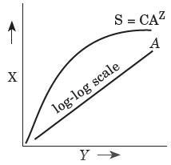  i) What does the given figure show?  (a) Rivet-popper hypothesis  (b) Species-area relationship  (c) Proportionate number of species of major taxa  (d) a-ecological diversity  (ii) Equation for relationship (A) between species richness and area is  (a) log S = log C + Z log A  (b) log C = log S + Z log A  (c) Z log A = log S + log C  (d) log S = log C + log A.  (iii) What is the value of slope of line or regression coefficient Z for frugivorous birds?  (a) 0.1-0.2  (b) 1.15  (c) 0.01-0.1  (d) 0.6-1.2  (iv) The shape of curve for relationship between species richness and areas for a wide variety of taxa is  (a) straight line  (b) parabola  (c) rectangular hyperbola  (d) bell shaped.  (v) Who gave this concept of increase in species richness with increasing area?  (a) Humboldt  (b) Odum  (c) Edward Wilson  (d) Paul Ehrlich  Assertion and Reason  Directions: In the following questions, a statement of assertion is followed by a statement of reason.  Mark the correct choice as:  (a) If both Assertion and Reason are true and Reason is the correct explanation of Assertion.  (b) If both Assertion and Reason are true but Reason is not the correct explanation of Assertion.  (c) If Assertion is true but Reason is false.  (d) If both Assertion and Reason are false.  Q.1Assertion:Ecosystem is the structural and functional unit of biosphere consisting of abiotic and biotic components which interact with each other and maintain a balance in nature.  Reason:In an ecosystem, energy and matter are continuously exchanged between living and non-living components.  Q.2The given graphs shows the productivity of an aquatic ecosystem measured in terms of dissolved oxygen produced and consumed by green 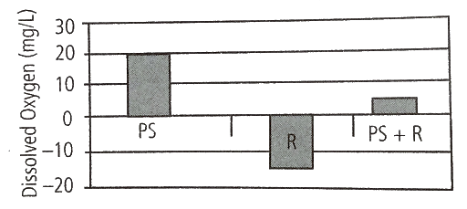n  and photosynthetic algae where PS=photosynthesis and R=respiration.  Q.3The given diagram represents the relationships between organisms in a remote point ecosystem. From this information. Which of the following is the most likely to be correct?  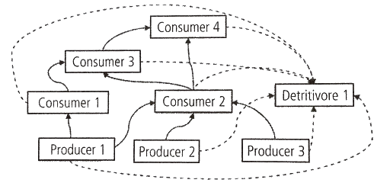  1.DDT present in the ecosystem would accumulate to the highest concentrations in the tissues of detrivore 1.  2.The introduction of consumer 4 individuals from an external population would lead a temporary increase in number of producer 2.  3.Disease in the producer 1population would lead to an increase in the producer 3 population.  4.Exterination of consumer 3 would cause a sustained increase in the population of consumer 2.  Multiple choice Question  Q.1Who introduced term Ecosystem?  (a) Leaneous  (b) Reiter  (c) Odum  (d) Aristotle  Q.2Soil developed from sedimented rock:  (a) Force Science  (b) Edaphology  (c) Pedogenesis  (d) All of these  Q3Soil particle determine the character of:  (a) Organisation  (b) Biomass  (c) Area capacity  Q.4Exchange of water in submerged plant:  (a) Stomata  (b) Normal surface  (c) Hydathode  (d) Lenticel Water  Q.5co-deficient contains:  (a) Large thin walled cells  (b) Large-vacuoles  (c) Membrane  (d) All of theseSoil plants

